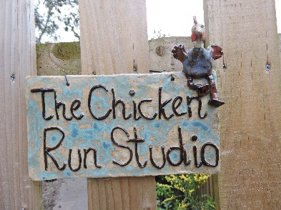
THE CHICKEN RUN STUDIO
Regular Pottery Tuition for 1 or 2 adults or those who want ongoing tuition
Two hours weekly is ideal for ensuring progress and it will give you the opportunity for continuity and to start to build up that muscle memory that goes with developing skill and techniques. (This is especially important with wheel throwing, which also requires lots of practice)
It is practice and repetition that reinforces skills and helps you to find what works for you. One on one I can ensure that good habits are established and that you play to your abilities. Not everyone has the same sized hands or strength and together we can make it work for you. I will ensure that you will adhere to the basic principles of working your hands together and maintaining stability and control. I haven’t the space to hold work or maintain their condition for long lengths of time and I would like you to be involved at all stages of the process.
From time to time you may want to call in for additional time to turn a pot or glaze to ensure you catch a kiln firing. Additional costing per hour is considered.
Tools, equipment, clay and glazes are included with tuition cost.
Each session is bespoke and led by your needs and may include:
• Hand building techniques including pinch, coil, slab, impressing
• Wheel thrown pottery techniques including wedging, centring, throwing, turning, glazing
or a combination of the above.

Contact details for Alison Holmans
www.chickenrunstudio.co.uk
Email: achholmans60@gmail.com
Phone: 01865 883165
Mobile: 07452 956 559

